Kubernetes多主节点集群搭建（Ubuntu 22.04.1）
Copyright@2025-01-10
Wrote by JunXiTang

参考文档
Bash
1.配置高可用kubernetes集群（真只是参考）
https://kubernetes.io/docs/setup/production-environment/tools/kubeadm/high-availability/
2.配置负载均衡器
https://github.com/kubernetes/kubeadm/blob/main/docs/ha-considerations.md#options-for-software-load-balancing
不使用加速器可用先配置hosts文件：
20.205.243.166 github.com
下载calico和flannel等网络插件：
185.199.108.133 raw.githubusercontent.com

基础机器和软件配置
Bash
Linux操作系统： Ubuntu 22.04.1
内核版本：
6.5.0-18-generic
基础软件：
Kubernetes版本：
V1.28.2
容器containerd版本：
github.com/containerd/containerd 1.7.12
网络插件版本：
calico版本：
v3.29.1
git工具：
薅官方脚本更新证书有效期时间
下载：
sudo apt install -y git
ssh服务：
ssh客户端和服务端
客户端自带
服务端下载：
sudo apt install -y openss-server

一、多主节点架构概念图

1.基本架构图(摘至Kubernetes.io)
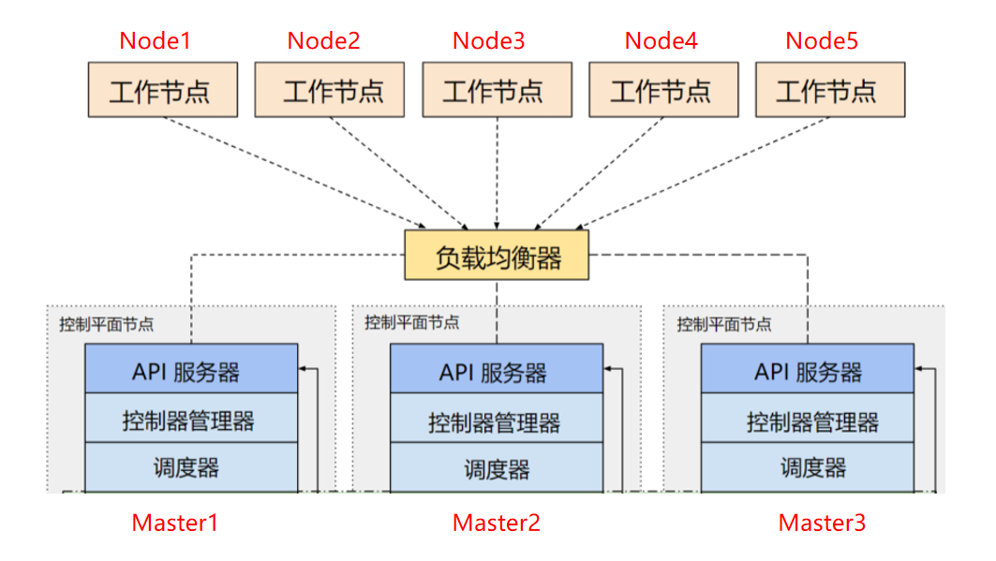

2.高可用etcd集群架构图（摘至kubernetes.io）
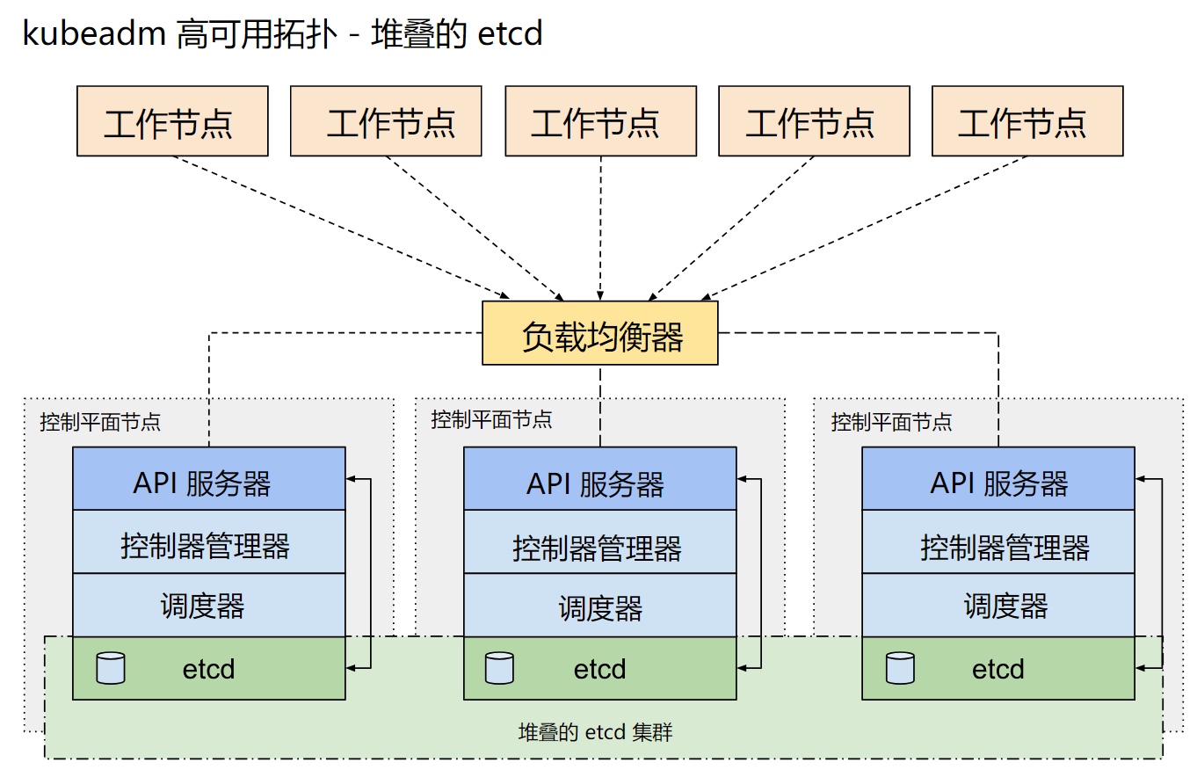

3.外部高可用ectd集群（摘至kubernetes.io）
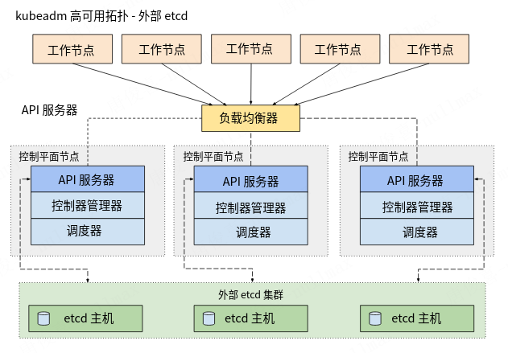

二、角色规划

1.角色分配
Bash
角色：
控制节点：
k8-master-01
k8-master-02
k8-master-03
负载均衡：
k8-apiserver-01
k8-apiserver-02
外部etcd存储：
k8-etcd-01
k8-etcd-02
k8-etcd-03
工作节点：
k8-slave-01
k8-slave-02

2.地址解析
Bash
sudo nano /etc/hosts

Bash
192.168.135.136 k8-master-01 #主节点1
192.168.135.135 k8-master-02 #主节点2
192.168.135.145 k8-master-03 #主节点3
192.168.135.143 k8-apiserver-01 #负载均衡器-Master
192.168.135.146 k8-apiserver-02 #负载均衡器-Backup
192.168.135.137 k8-slave-01 #工作节点1
192.168.135.134 k8-slave-02 #工作节点2
192.168.135.149 k8-etcd-01 #高可用etcd集群1
192.168.135.150 k8-etcd-02 #高可用ectd集群2
192.168.135.147 k8-etcd-03 #高可用etcd集群3

三、网络环境准备

1.转发 IPv4 并让 iptables 看到桥接流量(所有安装kubernetes的机器)
Bash
#添加模块
sudo tee /etc/modules-load.d/k8s.conf <<EOF
overlay
br_netfilter
EOF

Bash
#加载模块
sudo modprobe overlay
sudo modprobe br_netfilter

Bash
#设置网络参数
sudo tee /etc/sysctl.d/k8s.conf <<EOF
net.bridge.bridge-nf-call-ip6tables = 1
net.bridge.bridge-nf-call-iptables = 1
net.ipv4.ip_forward = 1
EOF

Bash
#即刻生效
sudo sysctl --system

2.确保配置已经启用
Bash
sysctl net.bridge.bridge-nf-call-iptables net.bridge.bridge-nf-call-ip6tables net.ipv4.ip_forward

四、关闭分区
Bash
sudo nano /etc/fstab
#nano
#Ctrl+O 保存
#Ctrl+X 退出
#一般系统有两种挂载磁盘方式
注释掉
#UUID=xxxx-xxxx-xxxx-xxxx swap swap defaults 0 0
或者
#/swapfile none swap sw 0 0
#非LVM安装ubuntu
sed -i 's@/swapfile@#/swapfile@g' /etc/fstab
#切勿注释掉系统分区
#否则无法正常开机
sudo swapoff -a
#重启系统以确保更改持久生效。
#请注意，在编辑/etc/fstab文件时要小心，因为不正确的更改可能会导致系统无法启动。如果你不确定，请先在非生产系统上尝试这些步骤。

五、配置ssh传输无密码密钥

1.生成秘钥
Bash
#生成密钥，按提示操作，也可以直接回车以接受默认设置。
#保持默认就行
#生成密钥过程中会让你输入密钥密码，不要输入其他的，回车默认即可，不然仍然需要输入密码
ssh-keygen -b 4096 -t rsa
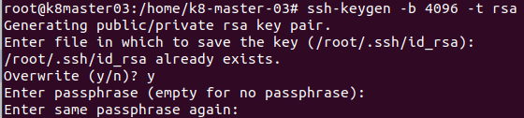
Bash
#默认秘钥文件位置
~ ./ssh/id_rsa.pub #公钥
~ ./ssh/id_rsa #私钥
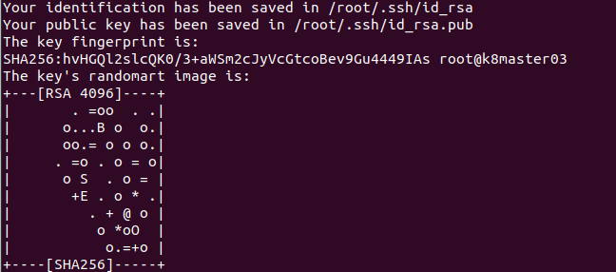

2.将公钥复制到远程服务器：
Bash
#复制到远程服务器
#其中user是远程服务器上的用户名，remote_host是远程服务器的地址。
ssh-copy-id -i ~/.ssh/id_rsa.pub user@remote_host

Bash
#example:
#k8-master-03上操作
ssh-copy-id -i ~/.ssh/id_rsa.pub k8-master-02@192.168.135.135
ssh-copy-id -i ~/.ssh/id_rsa.pub k8-master-01@192.168.135.136

3.登录远程服务器：
Bash
#这次登录不应再要求输入密码。
ssh user@remote_host
#以上步骤完成后，你就可以无密钥登录远程服务器了。

4.效果：
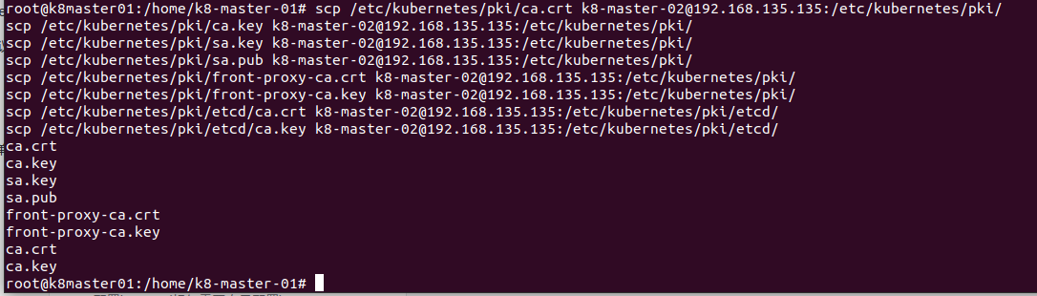

六、安装配置负载均衡器

1.安装
Bash
sudo apt install -y haproxy keepalived

2.配置keepalived(标红需要自己配置)
Bash
#创建keepalived.conf文件
sudo nano /etc/keepalived/keepalived.conf

Bash
! /etc/keepalived/keepalived.conf
! Configuration File for keepalived
global_defs {
script_user root
router_id VRRP-01
enable_script_security
}
vrrp_script check_apiserver {
script "/etc/keepalived/check_apiserver.sh"
interval 3
weight -2
fall 10
rise 2
}
vrrp_instance VI_1 {
state MASTER
interface ens33
virtual_router_id 50
priority 100
authentication {
auth_type PASS
auth_pass Kubernetes
}
virtual_ipaddress {
192.168.135.143
}
track_script {
check_apiserver
}
}

Bash
! /etc/keepalived/keepalived.conf
! Configuration File for keepalived
global_defs {
script_user root
router_id VRRP-02
enable_script_security
}
vrrp_script check_apiserver {
script "/etc/keepalived/check_apiserver.sh"
interval 3
weight -2
fall 10
rise 2
}
vrrp_instance VI_1 {
state BACKUP
interface ens33
virtual_router_id 50
priority 100
authentication {
auth_type PASS
auth_pass Kubernetes
}
virtual_ipaddress {
192.168.135.146
}
track_script {
check_apiserver
}
}

Bash
#创建check_apiserver.sh脚本文件
sudo nano /etc/keepalived/check_apiserver.sh

Bash
#!/bin/bash
#主备均衡器度需要配置
errorExit() {
echo "*** $*" 1>&2
exit 1
}
curl -sfk --max-time 2 https://localhost:6443/healthz -o /dev/null || errorExit "Error GET https://localhost:6443/healthz"

3.配置haproxy(标红需要自己配置)
Bash
#修改haproxy.cfg文件
sudo nano /etc/haproxy/haproxy.cfg
#清除掉原有内容

Bash
# /etc/haproxy/haproxy.cfg
#---------------------------------------------------------------------
# Global settings
#---------------------------------------------------------------------
global
log stdout format raw local0
daemon
#---------------------------------------------------------------------
# common defaults that all the 'listen' and 'backend' sections will
# use if not designated in their block
#---------------------------------------------------------------------
defaults
mode http
log global
option httplog
option dontlognull
option http-server-close
option forwardfor except 127.0.0.0/8
option redispatch
retries 1
timeout http-request 10s
timeout queue 20s
timeout connect 5s
timeout client 35s
timeout server 35s
timeout http-keep-alive 10s
timeout check 10s
#---------------------------------------------------------------------
# apiserver frontend which proxys to the control plane nodes
#---------------------------------------------------------------------
frontend apiserver
#bind *:${APISERVER_DEST_PORT}
bind *:6443
mode tcp
option tcplog
default_backend apiserverbackend
#---------------------------------------------------------------------
# round robin balancing for apiserver
#---------------------------------------------------------------------
backend apiserverbackend
option httpchk
http-check connect ssl
http-check send meth GET uri /healthz
http-check expect status 200
mode tcp
balance roundrobin
#server ${HOST1_ID} ${HOST1_ADDRESS}:${APISERVER_SRC_PORT} check verify none
server k8-master-01 192.168.135.136:6443 check verify none
server k8-master-02 192.168.135.134:6443 check verify none
server k8-master-03 192.168.135.145:6443 check verify none
# [...]

4.启用keepalived和haproxy
Bash
sudo systemctl enable/disable haproxy --now
sudo systemctl enable/disable keepalived --now

七、初始化kubernetes集群
1.提前下载、安装和配置好cantainerd,kubernetes,以及calico网络插件配置文件
2.准备好kubernetes和calico等网络插件所需镜像
下载安装请参考基础kubernetes集群搭建过程

1.配置Kubernetes初始化文件（任意主节点操作）
Bash
#导出默认配置
sudo mkdir /etc/kubernetes
sudo touch /etc/kubernetes/kubeadm-init.yaml
kubeadm config print init-defaults > /etc/kubernetes/kubeadm-init.yaml

Bash
#目前建议手动
#修改节点名字
nano /etc/kubernetes/kubeadm-init.yaml
#slave节点就改为对应的节点名
name: k8-master
#修改版本
kubernetesVersion: 1.28.2
#修改IP
advertiseAddress： 192.168.135.136 #your host
#修改镜像源
#把镜像修改为：
imageRepository: registry.aliyuncs.com/google_containers
#添加podSubnet:
podSubnet: 10.244.0.0/16
#添加controlPlaneEndpoint(VRRP虚拟IP):
controlPlaneEndpoint: "192.168.135.148:6443"

Bash
#使用指令
#k8-master-01
sed -i 's@node@k8master01@g' /etc/kubernetes/kubeadm-init.yaml
sed -i 's@1.2.3.4@192.168.135.136@g' /etc/kubernetes/kubeadm-init.yaml
#k8-master-02
sed -i 's@node@k8master02@g' /etc/kubernetes/kubeadm-init.yaml
sed -i 's@1.2.3.4@192.168.135.135@g' /etc/kubernetes/kubeadm-init.yaml
sed -i 's@1.28.0@1.28.2@g' /etc/kubernetes/kubeadm-init.yaml
sed -i 's@kubernetesVersion: 1.28.2@kubernetesVersion: 1.28.2\ncontrolPlaneEndpoint: "192.168.135.145:6443"@g' /etc/kubernetes/kubeadm-init.yaml
sed -i 's@registry.k8s.io@registry.aliyuncs.com/google_containers@g' /etc/kubernetes/kubeadm-init.yaml
sed -i 's@serviceSubnet: 10.96.0.0/12@serviceSubnet: 10.96.0.0/12\n podSubnet: 10.244.0.0/16@g' /etc/kubernetes/kubeadm-init.yaml

Bash
#/etc/kubernetes/kubeadm-init.yaml
apiVersion: kubeadm.k8s.io/v1beta3
bootstrapTokens:
- groups:
- system:bootstrappers:kubeadm:default-node-token
token: abcdef.0123456789abcdef
ttl: 24h0m0s
usages:
- signing
- authentication
kind: InitConfiguration
localAPIEndpoint:
advertiseAddress: 192.168.135.151
bindPort: 6443
nodeRegistration:
criSocket: unix:///var/run/containerd/containerd.sock
imagePullPolicy: IfNotPresent
name: k8-master-01
taints: null
---
apiServer:
timeoutForControlPlane: 4m0s
apiVersion: kubeadm.k8s.io/v1beta3
certificatesDir: /etc/kubernetes/pki
clusterName: kubernetes
controlPlaneEndpoint: "192.168.135.158:16443"
controllerManager: {}
dns: {}
etcd:
external:
endpoints:
- https://k8-etcd-01:2379
- https://k8-etcd-02:2379
- https://k8-etcd-03:2379
caFile: /etc/kubernetes/pki/etcd/ca.crt
certFile: /etc/kubernetes/pki/apiserver-etcd-client.crt
keyFile: /etc/kubernetes/pki/apiserver-etcd-client.key
imageRepository: registry.aliyuncs.com/google_containers
kind: ClusterConfiguration
kubernetesVersion: 1.28.2
networking:
dnsDomain: cluster.local
serviceSubnet: 10.96.0.0/12
podSubnet: 10.244.0.0/16
scheduler: {}

2.初始化其中一个master节点
Bash
#任意一台master节点执行
kubeadm init --config kubeadm-init.yaml
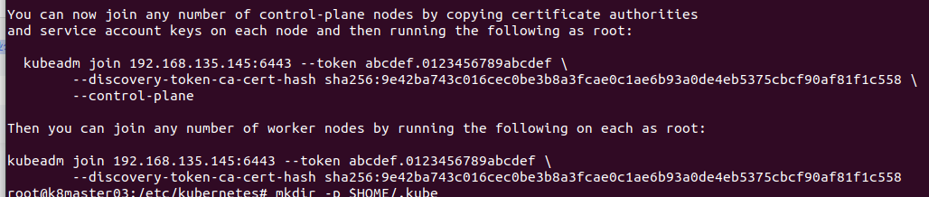

3.拷贝证书并加入集群
1.控制节点加入前拷贝证书（依情况修改）
Bash
#k8-master-n
mkdir /etc/kubernetes/pki/etcd #存储证书
sudo chown k8-master-n:k8-master-n /etc/kubernetes
sudo chown k8-master-n:k8-master-n /etc/kubernetes/pki#修改文件所有者
sudo chown k8-master-n:k8-master-n /etc/kubernetes/pki/etcd

Bash
#k8-master-n -> k8-master-01
scp /etc/kubernetes/pki/ca.crt k8-master-01@192.168.135.136:/etc/kubernetes/pki/
scp /etc/kubernetes/pki/ca.key k8-master-01@192.168.135.136:/etc/kubernetes/pki/
scp /etc/kubernetes/pki/sa.key k8-master-01@192.168.135.136:/etc/kubernetes/pki/
scp /etc/kubernetes/pki/sa.pub k8-master-01@192.168.135.136:/etc/kubernetes/pki/
scp /etc/kubernetes/pki/front-proxy-ca.crt k8-master-01@192.168.135.136:/etc/kubernetes/pki/
scp /etc/kubernetes/pki/front-proxy-ca.key k8-master-01@192.168.135.136:/etc/kubernetes/pki/
scp /etc/kubernetes/pki/etcd/ca.crt k8-master-01@192.168.135.136:/etc/kubernetes/pki/etcd/
scp /etc/kubernetes/pki/etcd/ca.key k8-master-01@192.168.135.136:/etc/kubernetes/pki/etcd/
scp /etc/kubernetes/admin.conf k8-master-01@192.168.135.136:/etc/kubernetes/
#k8-master-n -> k8-master-02
scp /etc/kubernetes/pki/ca.crt k8-master-02@192.168.135.135:/etc/kubernetes/pki/
scp /etc/kubernetes/pki/ca.key k8-master-02@192.168.135.135:/etc/kubernetes/pki/
scp /etc/kubernetes/pki/sa.key k8-master-02@192.168.135.135:/etc/kubernetes/pki/
scp /etc/kubernetes/pki/sa.pub k8-master-02@192.168.135.135:/etc/kubernetes/pki/
scp /etc/kubernetes/pki/front-proxy-ca.crt k8-master-02@192.168.135.135:/etc/kubernetes/pki/
scp /etc/kubernetes/pki/front-proxy-ca.key k8-master-02@192.168.135.135:/etc/kubernetes/pki/
scp /etc/kubernetes/pki/etcd/ca.crt k8-master-02@192.168.135.135:/etc/kubernetes/pki/etcd/
scp /etc/kubernetes/pki/etcd/ca.key k8-master-02@192.168.135.135:/etc/kubernetes/pki/etcd/
scp /etc/kubernetes/admin.conf k8-master-02@192.168.135.135:/etc/kubernetes/
#k8-master-n -> k8-master-03
scp /etc/kubernetes/pki/ca.crt k8-master-03@192.168.135.145:/etc/kubernetes/pki/
scp /etc/kubernetes/pki/ca.key k8-master-03@192.168.135.145:/etc/kubernetes/pki/
scp /etc/kubernetes/pki/sa.key k8-master-03@192.168.135.145:/etc/kubernetes/pki/
scp /etc/kubernetes/pki/sa.pub k8-master-03@192.168.135.145:/etc/kubernetes/pki/
scp /etc/kubernetes/pki/front-proxy-ca.crt k8-master-03@192.168.135.145:/etc/kubernetes/pki/
scp /etc/kubernetes/pki/front-proxy-ca.key k8-master-03@192.168.135.145:/etc/kubernetes/pki/
scp /etc/kubernetes/pki/etcd/ca.crt k8-master-03@192.168.135.145:/etc/kubernetes/pki/etcd/
scp /etc/kubernetes/pki/etcd/ca.key k8-master-03@192.168.135.145:/etc/kubernetes/pki/etcd/
scp /etc/kubernetes/admin.conf k8-master-03@192.168.135.145:/etc/kubernetes/

2.加入集群
1.)控制节点加入
Bash
#k8-master-01
scp k8-master-03@192.168.135.145:/etc/kubernetes/admin.conf /etc/kubernetes/
mkdir -p $HOME/.kube
sudo cp -i /etc/kubernetes/admin.conf $HOME/.kube/config
sudo chown $(id -u):$(id -g) $HOME/.kube/config
#Alternatively, if you are the root user, you can run:
export KUBECONFIG=/etc/kubernetes/admin.conf

Bash
#k8-master-02
scp k8-master-03@192.168.135.145:/etc/kubernetes/admin.conf /etc/kubernetes/
mkdir -p $HOME/.kube
sudo cp -i /etc/kubernetes/admin.conf $HOME/.kube/config
sudo chown $(id -u):$(id -g) $HOME/.kube/config
#Alternatively, if you are the root user, you can run:
export KUBECONFIG=/etc/kubernetes/admin.conf

Bash
#You can now join any number of control-plane nodes by copying certificate authorities and service account keys on each node and then running the following as root:
kubeadm join 192.168.135.145:6443 --token xxxx.xxxxxx \
--discovery-token-ca-cert-hash sha256: xxxxxxx..xxxx\
--control-plane
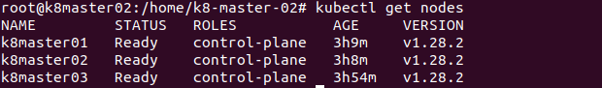
2.)工作节点加入
Bash
mkdir -p $HOME/.kube
sudo cp -i /etc/kubernetes/admin.conf $HOME/.kube/config
sudo chown $(id -u):$(id -g) $HOME/.kube/config
#Then you can join any number of worker nodes by running the following on each as root:
kubeadm join 192.168.135.145:6443 --token xxxx.xxxxxx \
--discovery-token-ca-cert-hash sha256:xxxxx....xxxxxxx
#example:
kubeadm join 192.168.135.145:6443 --token abcdef.0123456789abcdef \
--discovery-token-ca-cert-hash sha256:d77d919dca4a5a9b79362ca70ca2a4d819a0e87b813f56fdffa7df68d865d476
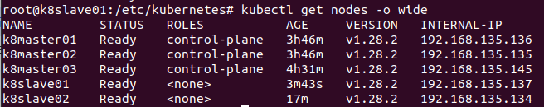

4.删除节点
1.)获取所有节点
Bash
#在Kubernetes中删除节点的步骤如下：
#获取节点列表并确定要删除的节点‌：
#使用命令kubectl get nodes获取所有节点的名称
kubectl get nodes
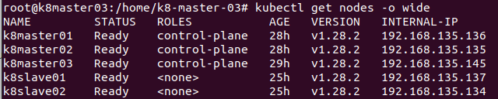
2.）驱除节点
Bash
#驱逐节点上的Pod‌：
#使用kubectl drain命令驱逐要删除节点上的Pod，以确保在删除节点时不会中断应用程序。
#例如，kubectl drain <node-name> --ignore-daemonsets，其中<node-name>是要删除的节点名称。
kubectl drain <node-name> --ignore-daemonsets
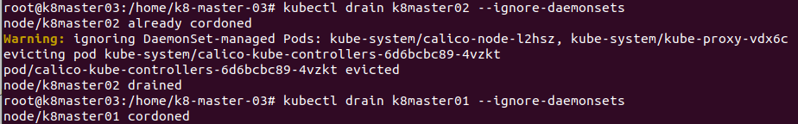
3.)删除节点
Bash
#删除节点‌：
#使用kubectl delete node <node-name>命令删除节点。例如，kubectl delete node 127.0.0.1，其中127.0.0.1是要删除的节点名称。
kubectl delete node <node-name>
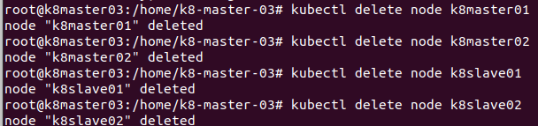

4.）重置kubernetes
Bash
#重置节点‌：
#如果需要在删除节点后重新将其加入集群，可以在该节点上执行kubeadm reset命令来清理Kubernetes集群信
kubectl reset

八、更新证书有效期（依需操作/可选）

1.查看目前证书有效期
Bash
openssl x509 -in /etc/kubernetes/pki/apiserver.crt -noout -text | grep Not

2.下载证书
Bash
git clone https://github.com/yuyicai/update-kube-cert.git
cd update-kube-cert
chmod 755 update-kubeadm-cert.sh

3.更新有效期
Bash
#修改过期时间
sed -i '1,$s/CERT_DAYS=3650/CERT_DAYS=36500/g' update-kubeadm-cert.sh
./update-kubeadm-cert.sh all
./update-kubeadm-cert.sh all --cri containerd
openssl x509 -in /etc/kubernetes/pki/apiserver.crt -noout -text | grep Not

